A Reduced-Order Model Simulation of Thermal Runaway Propagation in Lithium-Ion Battery Modules

Abstract

The reduced-order model simulates battery cell temperature profiles during the TR propagation process by taking into consideration various of heat transfer means, aiming to identify the key factors contributing to the cell-to-cell propagation. The simulation results were validated against the large-scale experiment. The results showed that the TR propagation was facilitated by multiple heat transfer means from those cells that have failed to those who have not. The main contributing factors to TR varied from cell to cell. The polycarbonate module enclosure fire induced by the previous failing cells plays an important role in causing TR propagation.

Introduction

Thermal runaway (TR) of a battery cell is a self-reinforcing energy release process in which an increased cell temperature leads to unconfined release of battery chemical energy through a series of exothermic reactions and further heat up of the battery cell[1]. Thermal runaway of a cell can result in catastrophic battery failures, which can lead to fires or explosions[2]. TR of a cell inside a battery module can be propagated to the rest of the cells when the large amount of heat released by the failed cell increases the temperature of adjacent cells and triggers TR[3]. The significant safety hazard imposed by TR propagation within a module necessitates further research on the cell-to-cell TR propagation within a battery module.

While experimental study on TR propagation is crucial, the number of large-scale experimental studies that aim to reveal the characteristics of the TR propagation is not adequate due to the time, funding and safety limitations. Modeling methods offer an alternative approach that can provide valuable insights into complex TR propagation processes. Reduced-order modeling provides a fast, easy-to-implement simulation approach to identify the key factors contributing to the cell-to-cell TR propagation[4], and hence can provide valuable insights into for the battery module TR behaviors and potential mitigation strategies. In this paper, a developed reduced-order simulation model to predict cell-to-cell TR propagation within a prismatic module was presented. This reduced-order model aims to address the following topic: 1) what are the factors contributing to the cell-to-cell TR propagation inside the battery module? 2) what are the potential measurements that might mitigate, even prevent the TR propagation?

Research Method

Experimental Setup

The research carried out the experimental study[5] on the prismatic battery module TR propagation and collected important data for the development of the model development. The experimental setup was shown in Figure 1. In the experiment, a battery module, which had 14 prismatic cells and whose enclosure is made of polycarbonate, was failed by heating up the first cell using external heater and allowing the TR to propagate from this initiating cell to the rest of the cells. The surface temperatures of the cells were measured, and the total module mass change with time was recorded. In addition, a detailed video recording of the module TR failure was conducted to better analyze the module TR. The experimental results served as a validation baseline for the developed model.

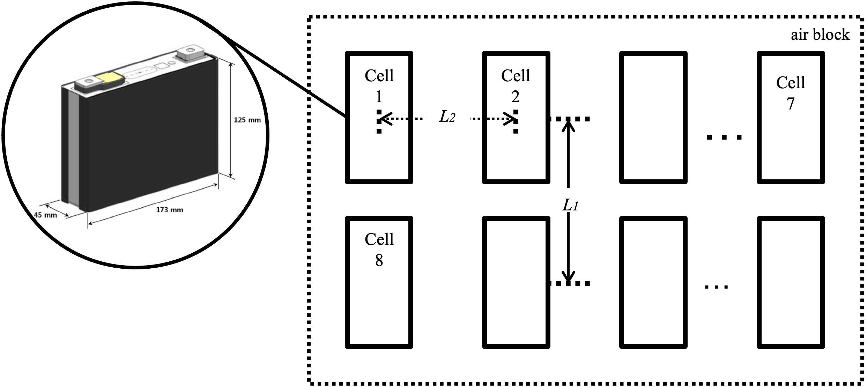

Figure 1 Battery module experimental setup

Improved Model Based on Flame Propagation

Based on the previous simulations, the improved model based more on flame propagation was developed.

In this improved model, the geometry remained unchanged. The battery cell model was having 173 mm in length, 45 mm in width and 125 mm in height. The battery cells were placed into 2 rows in the module, with each row having 7 cells. The way cell was placed in the module was that the module long edge was parallel to the cell width. Cell 1 was placed in the northeastern corner of the module. The east-west gap between two adjacent cells was 20 mm, and the north-south gap between two adjacent cells was 10 mm. The east-west spacing between cells and the module block was 10 mm and the north-south spacing was 1 mm.

Figure 2 Improved model geometry

The model was developed to be lump-sum model battery model aiming to simulate the energy balance and the mass change of each battery cells. All 14 cells were treated as lump-sum and each of them was assumed to have a constant specific heat. Each cell was assumed to go into thermal runaway once the lump-sum temperature reached threshold temperature. The states of interest were the temperature and mass profiles of each of the cells. During the beginning of the simulation, the cell 1 was externally heated using a heating rate of approximately 5C/min until it went into thermal runaway. The external heater was turned off right after cell 1 went into TR, and how the TR was propagated into rest of the cells was simulated by the model.

The improved reduced-order model considered the following mass and energy transfer mechanisms:

**The mass loss and energy release when the cell went into TR:** the cell was assumed to go into thermal runway when lump-sum temperature reached Tign = 180 °C. In the previous experiments, the gas venting was found to last approximately 7 seconds after the onset of TR where sudden temperature rise took place. Gas venting rate and total venting volume under standard condition was measured and recorded from the experiments. Total cell mass loss from gas venting was found to be 0.286 kg. It was also found that each cell was found to lose approximately 0.9 kg of mass after the thermal runaway experiments. Given all these findings, we assumed that both mass loss due to venting, and the thermal runaway energy release took place right at the onset of TR and lasted for 7 seconds. We further assumed that instantaneous particle venting rate was always 2.14 times the gas venting rate, leading to a total of 0.286 kg mass loss due to gas venting and 0.614 kg mass loss due to particle venting after 7 seconds. The cell heat release rate was modeled to be the mass loss rate times the measured energy release rate from cell TR chemical reaction, which was 1000 kJ/kg. In additional to gaining those energy released from TR, the cell also lost internal energy due to the gas and particle venting.

**The radiation between two adjacent cells:** the cell was assumed to see only the adjacent cells. The adjacent cells of a cell will be the 5 (or 3) neighbors of this certain cell. There were 3 scenarios regarding this modeling, and in all 3 scenarios, the percentage of radiation power transmitted from one cell to the other was calculated by calculating the radiation power transmitted from the face(s) of the emitting cell to the face(s) of the emitted cell. The calculation was based on the view factor calculation provided by Isidoro Martinez.

* Two adjacent cells neighboring each other along the cell width direction: two cells are separated by a fixed north-south gap of d. The area of the faces that saw each other were the same and these two faces, highlighted in red, were assumed to be the only face of each cell that could see the other. The view factor from one cell to the other could be calculated by simplifying them to be two equal, concentric rectangles facing each other parallel, with distance d and rectangle shape L X H, where L and H were the cell length and height, respectively.

* Two adjacent cells neighboring each other along the cell length direction: as like the previous scenario, the two nearest faces were assumed to be the only surfaces of the cell that were able to see the other. Again, the radiation power transmission between these two cells were modeled by calculating the radiation heat transfer between these two cells. The two surfaces were again treated as two equal, concentric rectangles facing parallel to each other, with distance d’ equal to the east-west gap defined above, and the two dimension of the rectangles equal to cell width W and cell height H respectively.

* Two adjacent cells neighboring diagonally: although it was a complicated model, it was assumed for now that only the two nearest surfaces of these two cells were able to see the other cell. While most of the assumptions in the previous scenario stood, now two surfaces were no longer concentric, but were off center by a distance of d+W, where d was the north-south gap of the cell and the W was the cell width.

Given all these geometry conditions, a 14-by-14 radiation heat transfer matrix A, where the (i,j) element Aij indicated the ratio of the emitted radiation heat rate of cell i going into the cell j, was calculated. Matrix A was used to calculate the radiation energy transfer throughout the process of TR propagation.

**The conduction between two adjacent cells along the cell width direction**: the cell bulge at the large side surface was found during the experiments. From the experiments, it was found out that the cell bulged for 10 mm at the end of TR. In the model, the north-south gap was also 10 mm. Given all these, the following model assumption was made: when none of the two adjacent cells (along the cell width direction) went into TR, no conduction was assumed; when one of the two cells went into TR, it was assumed that two cells got into direct contact, with conduction surface half of the total large side surface. When both of the two cells went into TR, the conduction surface was assumed to be full large side surface. The conduction was assumed to overcome the thermal conductivity resistance of air, whose thermal conductivity changed as temperature.

**Flame propagation and flame heating of the cell:** from the experiments, it was observed that once the cell went into TR, the polycarbonate container was broken down and it started combusting. Current assumption of the flame propagation included the following:

1. Flame wave was a one-time flame wave generated by cell 1 TR, and had its wave front and wave back. Currently, no flame waves were generated since the cell 2 TR.
2. Both the wave front and wave back radii increased with time, and the region between them would experience flame heating.
3. The front wave Vf was assumed to be proportional to (Af)α, where Af was the circle area the wave front covered, and α was a coefficient which for now was assumed to be between 0 and 0.5. That also meant that Vf ∝(Rf)2α, where Rf was the radius of the wave front. The change of Rf/Af could be modeled by the derivative equations below:

If α was not equal to 0.5, the obtained flame wave front change profile is shown below:

where Rf,0 was the initial wave front radius, and Vf,0 was the initial wave propagation velocity. Rf,0 was currently set to be the width of the cell, and Vf,0 was set to be 2mm/s.

If α = 0.5, then the final Rf formula is shown below:

The back of the flame wave propagation rate was affected by current flame front radius Rf, current flame back radius Rb and the burnout time τ. The relationship is shown below:

The ODE itself could not be solved analytically and was solved numerically once Rf was determined. Currently τ was set to be 110 seconds but was a variable subject to tuning.

1. While exposed to the flame, all the cell side and top surfaces will be accepting heat from flame, and the heat inflow flux q’’ was assumed to be 30kW/m2. When the wave front reached the point of the certain cell closest to the flame origin, the cell area exposed to the flame increased linearly with Rf until all side & top surfaces were engulfed by flames when the wave front reached the point on the cell farthest from its origin. When the flame wave back reached the point of the certain cell closest to the flame origin, the cell area exposed to the flame decreased linearly with Rb until all side & top surfaces were no longer engulfed by flames when the wave back reached the point of the cell farthest from the flame origin. The formula was summarized to be below:

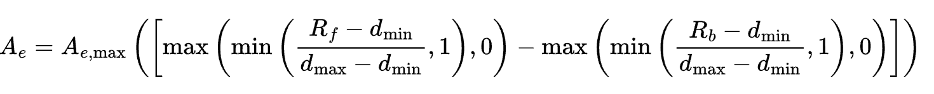

where Ae was the current cell area exposed to the flame, and Ae,max was the cell maximum possible area exposed to the flame.

Current model has been implemented and currently a parameter optimization was needed to find the optimal parameter set that could align the simulation results with the experimental results. The parameters to be tuned were listed below in Table 1.

Table 1 Parameters to be tuned

|  |  |
| --- | --- |
| α | Flame velocity propagation power coefficient |
| Vf,0 | Initial flame wave front propagation velocity (m/s) |
| τ | Burnout time for the polycarbonate (s) |
| q’’ | The cell heat intake by flames at the surface |
| N/A | Whether to allow flame generated only when at cell 1 TR, or allow individual flames to be generated every time a cell failes |

Currently, this improved model based on flame propagation was included in the “latest_sim.py” in the repo. Its auxiliary file is “auxiliary_new.py” and has been put in the same directory for convenience.

Results and Discussions

----

Conclusions

----

References

[1] C. F. Lopez, J. A. Jeevarajan, and P. P. Mukherjee, “Experimental Analysis of Thermal Runaway and Propagation in Lithium-Ion Battery Modules,” *J. Electrochem. Soc.*, vol. 162, no. 9, p. A1905, Jul. 2015, doi: 10.1149/2.0921509jes.

[2] X. Feng, L. Lu, M. Ouyang, J. Li, and X. He, “A 3D thermal runaway propagation model for a large format lithium ion battery module,” *Energy*, vol. 115, pp. 194–208, Nov. 2016, doi: 10.1016/j.energy.2016.08.094.

[3] S. Gao *et al.*, “Experimental Study on Module-to-Module Thermal Runaway-Propagation in a Battery Pack,” *J. Electrochem. Soc.*, vol. 166, no. 10, p. A2065, Jun. 2019, doi: 10.1149/2.1011910jes.

[4] Z. Y. Jiang, Z. G. Qu, J. F. Zhang, and Z. H. Rao, “Rapid prediction method for thermal runaway propagation in battery pack based on lumped thermal resistance network and electric circuit analogy,” *Applied Energy*, vol. 268, p. 115007, Jun. 2020, doi: 10.1016/j.apenergy.2020.115007.

[5] E. J. Archibald, “Fire & explosion hazards due to thermal runaway propagation in lithium-ion battery systems,” Thesis, 2021. doi: 10.26153/tsw/13712.